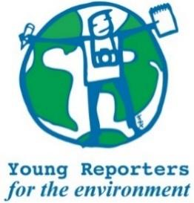
YRE International Competition
Competition entry form 2024/2025
Category: Video

Questions marked with * must be answered.
Age group* | ☐ 11-14 years  ☐ 15-18 years  ☐ 19-25 years
Name of student(s)*
Age(s) of students as of National Competition deadline*
Name of school*
Town and Postcode of school*
Title of the submission (no more than 140 characters)*
What type of video is the submission?* | ☐ Long-from Reporting Video (Long-from Reporting Videos are similar to mini-documentaries. They are based on news, events, history, facts etc., and use elements of direct observation, research, interviews and documentation.)  ☐ Short-form Campaign Video (Environmental Campaign Videos aim to raise awareness of an issue, promote certain values, and/or inspire positive action through live images. The campaign story can be staged with the intention of sending a message to the viewers)
Is the video max. 3 minutes? (This does not include credit roll)* | ☐ Yes / ☐ No
Is the format of the video compatible with YouTube?* | ☐ Yes / ☐ No
Is the title within 140 characters?* | ☐ Yes / ☐ No
Is the video focused on a pertinent (real and current) local issue?* | ☐ Yes / ☐ No
Does the video include relevant and feasible solutions to the environmental issue(s) presented in the video?* | ☐ Yes / ☐ No
Is the video made of at least 70% of the student's own original video footages, photos and audio?* | ☐ Yes / ☐ No
Are the sources used in the video cited in the credit roll or in a bibliography in MLA format under the video?* | ☐ Yes / ☐ No
Where has the submission been disseminated?* | ☐ Personal Sphere (through social media such as Instagram, Twitter, YouTube, or a personal blog)  ☐ School Community (through the school newspaper, website,etc.)  ☐ Eco-Schools NI (through the organisation's website or social media channels)  ☐ National Media (through newspaper, TV, website)  ☐ Other
Please attach or list evidence of dissemination (links and/or photos) that show where your submission was shared with others.*
Student(s)' explanation of how the submission addresses the link between the topic and the chosen Goal(s)*
You can read about the SDGs here: https://sdgs.un.org/goals

