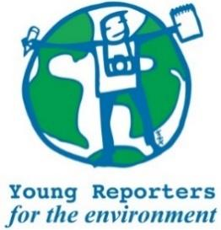
YRE International Competition
Competition entry form 2025/2026
Category: Photo Story (3-5 photos)

Questions marked with * must be answered.
Name of student(s)*
Age(s) of students as of National Competition deadline (24/4/2026)*
Name of school*
Town and Postcode of school*
Title of the submission (within 140 characters)*
Is the title no more than 140 characters?* | ☐ Yes / ☐ No
Does each photo have a short caption of max. 20 words?* | ☐ Yes / ☐ No
Copy the captions for each photo in the box to the right.*

Does the photo story have a short description of max. 100 words that explains the link with environmental sustainability and/or a solution to the issue?* | ☐ Yes / ☐ No
Copy the description in the box to the right.*

Are the photos a fair and truthful representation of reality and the subject and/or scene has not been manipulated or altered?* | ☐ Yes / ☐ No
Do the photos and/or descriptions/captions include relevant and feasible solutions to the environmental issue presented in the photos?* | ☐ Yes / ☐ No
Are the sources used in the description and/or captions cited in footnotes or MLA style?* | ☐ Yes / ☐ No
Are the original photos attached separately digitally as .jpg or .png format with a resolution of no less than 150-300 dpi?* | ☐ Yes / ☐ No
Where has the submission been disseminated?* | ☐ Personal Sphere (through social media such as Instagram, Twitter, YouTube, or a personal blog)  ☐ School Community (through the school newspaper, website, or as a poster or flyer in the school building.)  ☐ Eco-Schools NI (through the organisation's website or social media channels)  ☐ National Media (through newspaper, TV, radio)  ☐ Other
Please attach or list evidence of dissemination (links and/or photos) that show where your submission was shared with others.*
Student’s brief explanation of how the submission topic is linked to at least one of the UN Sustainable Development Goals*
You can read about the SDGs here: https://sdgs.un.org/goals

