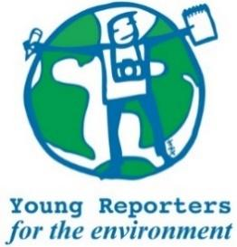
YRE International Competition
Competition entry form 2025/2026
Category: One Take Photo

Questions marked with * must be answered.
Name of student(s)*
Age(s) of students as of National Competition deadline*
Name of school*
Town and Postcode of school*
Title of the submission (within 140 characters)*
What is the title?
Is the title within the limit of max. 140 characters?* | ☐ Yes / ☐ No
Does the photo have a description of max. 100 words and a caption of max. 20 words? OR only a description of max. 120 words?* | ☐ Yes / ☐ No
Please copy your caption (if you have one) and your description in the box to the right.

Please your description in the box to the right.*

Is the photo a fair and truthful representation of reality and the subject and/or scene has not been manipulated or altered?* | ☐ Yes / ☐ No
Does the description/caption include relevant and feasible solutions to the environmental issue presented in the photo?* | ☐ Yes / ☐ No
Are the sources used in the description and/or caption cited in footnotes or MLA style?* | ☐ Yes / ☐ No
Was the original photo attached separately digitally as .jpeg or .png format with a resolution of not less than 150-300 dpi?* | ☐ Yes / ☐ No
Where has the submission been disseminated?* | ☐ Personal Sphere (through social media such as Instagram, Twitter, YouTube, or a personal blog)  ☐ School Community (through the school newspaper, website, or as a poster or flyer in the school building.)  ☐ Eco-Schools NI (through the organisation's website or social media channels)  ☐ National Media (through newspaper, TV, radio)  ☐ Other
Please attach or list evidence of dissemination (links and/or photos) that show where your submission was shared with others.*
Student(s)' explanation of how the submission addresses the link between the topic and the chosen Goal(s)*
You can read about the SDGs here: https://sdgs.un.org/goals

