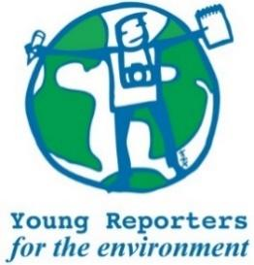
YRE International Competition
Competition entry form 2025/2026
Category: Article

Age Group* | ☐ 11-14 years  ☐ 15-18 years  ☐ 19-25 years
Country of residence*
Name of student(s)*
Age(s) of students as of National Competition deadline (24/4/2026)*
Name of school*
Town and Postcode of school*
Title of the submission (max. 140 characters)*
Is the submission focused on a pertinent (real and current) local issue?* | ☐ Yes / ☐ No
Does the submission include relevant, feasible, and constructive solutions to the environmental issues presented?* | ☐ Yes / ☐ No
Does the submission meet the limitation of word length max. 1000 words?* | ☐ Yes / ☐ No
Please copy the title of the article in the box to the right.
Is the title within 140 characters?* | ☐ Yes / ☐ No
Are the sources used in the article cited in footnotes or MLA style?* | ☐ Yes / ☐ No
Does the article include 1-3 photos/infographics with sources and captions of max. 20 words for each?* | ☐ Yes / ☐ No
Please copy the captions for each photo in the box to the right.
Are the photos attached separately from the article as .JPEG or .PNG files?* | ☐ Yes / ☐ No
Where has the submission been disseminated?* | ☐ Personal Sphere (through social media such as Instagram, Twitter, YouTube, or a personal blog)  ☐ School Community (through the school newspaper, website, or as a poster or flyer in the school building.)  ☐ Eco-Schools NI (through the organisation's website or social media channels)  ☐ National Media (through newspaper, TV, radio)  ☐ Other
Please include links or photos as evidence of dissemination (links and/or photos) that show where your submission was shared with others.*
Student’s brief explanation of how the submission topic is linked to at least one of the UN Sustainable Development Goals*
You can read about the SDGs here: https://sdgs.un.org/goals

