
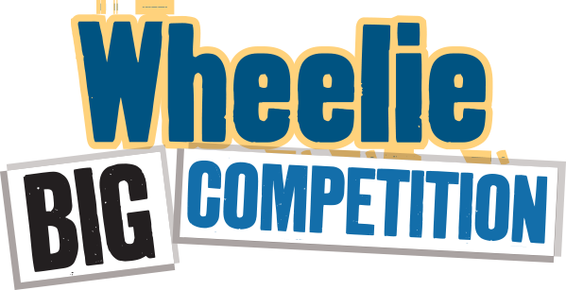

Entry 2024-25
Submit a brief description below of the actions you took at school and at home to improve recycling and reduce waste. No more than 250 words in total – don’t forget to mention food waste actions! Include any waste audit information you have. You may include up to 3 photos with your written answer.

School name:

At school (200-250 words):

At home (50 words optional):

Photos – Copy Below:

Submit your entry by 7th February 2025 to your field officer and eco-schools@keepnorthernirelandbeautiful.org

Schools will be awarded their prizes at the Green Flag Awards ceremonies in June.
Prizes are - First Place - £500
Second Place - £300
Third Place- £200

