
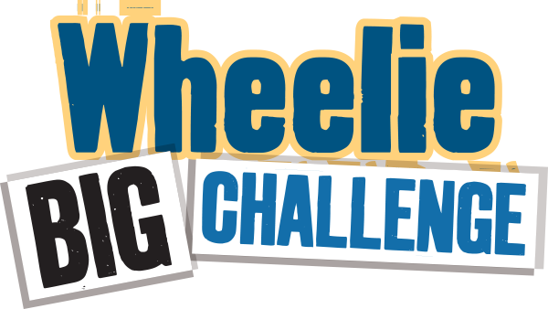
Worksheet - Waste Audit 2
Detailed Audit - What’s happening inside the school?

The aim of this task is to find out what is in your waste bins that could be recycled. Do not weigh recycling bins for this task – although you may want to do that separately. You will need gloves, scales and perhaps a plastic sheet for this activity.

Choose 3-5 small waste bins from a variety of areas (e.g. classrooms, office, ICT room, staff room) towards the end of the day. Note you will audit the same bins as you did for Audit 1. Separate each bin into three categories: recyclable, non-recyclable, and food waste. Weigh each (in grams) and record in the chart below. (Remember to save these results in your Data Zone!)
 | Mixed Dry Recyclables  (e.g. paper, card, plastic, yoghurt pots, tins)  / grams | Compostable Food  (e.g. crusts, fruit, teabags)  / grams | Non-Recyclable  (e.g. wrappers, cling film, pens, straws, tissues)  / grams | Overall weight  (e.g. everything in the bin)  / grams
Bin 1 from:

Bin 2 from:

Bin 3 from:

Bin 4 from:

Bin 5 from:

Total weight
Percentage | _________% | _________% | _________% | 100%

Has there been an improvement from waste Audit 1? Dry Recycling % improvement ____________ Food Recycling % improvement ____________

To complete your bin Audit 2, you can also check your single-use items!
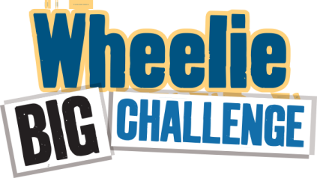
From the mixed dry recyclables and the non-recyclable items, select the ones in the table below that are single-use and count how many of each item you can find.
Item | Cups | Cutlery (forks, spoons, stirrers) | Straws | Food packaging | Yogurt Pots | Plastic bottles | Cling film | Plates | Lids
Number

WELL DONE FOR COMMITTING TO REDUCE SINGLE-USE PLASTIC! NOW YOU ARE READY TO UPDATE YOUR PLASTIC PROMISE HERE: https://www.liveherelovehere.org/cgi-bin/PlasticPromiseMakeYourPromise

Simple Audit - What’s happening outside? Has anything changed from Audit 1?
Take a sneak peek. What’s in the waste/landfill bins? Can you see recyclable items in there? List any that you see:

Is this an improvement from Audit 1?

*Don’t forget to send your audits and competition entry form to eco-schools@keepnorthernirelandbeautiful.org for a chance to win up to £500!

